Within the framework of the EU-funded project ‘FEM-UNITED - United to prevent IPV/DV Femicide in Europe’, the FEM-UNITED partnership are launching a comparative report on the findings of the FEM-UNITED research study on the prevalence and characteristics of femicide in five European countries.
Every day around the world, 137 women and girls are killed due to their gender by a family member or by a current or former intimate partner.
Femicide – the intentional killing of women and girls because they are women – is not only the most extreme form of gender-based violence against women, but also the most violent manifestation of discrimination against them.
The FEM-United project seeks to shine a spotlight on the urgent need to develop and implement effective strategies for preventing femicide. The project specifically focuses on the prevention of intimate partner femicide, the killings of women and girls committed in the context of intimate partner violence and/or domestic violence. A key way the project has contributed to this is with the development of an evidence base, through the collection of data on femicide across 5 European countries. The comparative report collates all the data and findings of this data collection process and provides a comparative analysis.
The FEM-United research showed that in 2019-2020, 629 women were killed in Cyprus, Germany, Malta, Portugal and Spain. 60% were killed by a current or former intimate partner.
The comparative report highlights key findings across the five European countries, including:
- 629 femicides were committed between 2019-2020 across the five European countries: the majority of the femicides were committed in Germany; however, the population-based rate was highest in Cyprus, followed by Portugal and Malta.
- Intimate partner femicide is the most common form of femicide: 60% of all identified victims were killed by a current or former intimate partner; the majority of killings took place in the victim’s and/or perpetrator’s home.
- Existing data collection processes on femicide are inadequate and do not take into account the gender dimensions of femicide, including the existence of IPV/DV: only Spain has instituted robust/comprehensive data collection processes on femicide, recognising the link between femicide and gender-based violence.
- There is no clear set of personal or background characteristics of victims and perpetrators indicating a higher risk of femicide common to all countries: there is a diversity of victims and perpetrators in terms of age, education, occupation, socio-economic status and migration background.
- Femicides are mainly committed by men: Over 99% of all perpetrators were male.
- Despite a history of intimate partner violence, there had been little to no involvement or support from the authorities prior to the femicides: only a small number of cases were known to the police or to the support system, and in an even smaller number of cases were measures, such as protection orders, taken to protect the victim.
- The media frequently romanticise and sensationalise cases of femicide, portraying cases of femicide as isolated incidents and employing language which is victim blaming or which reproduces sexist stereotypes.
- Gender inequality, a primary cause of discrimination and violence against women, persists in all of the countries: although to varying degrees, the persistence of structural inequalities between women and men is notable in all of the countries.
The comparative report sets out the following recommendations for governments and states to better protect women and prevent femicide:
- Recognize that gender-related killings of women and girls are femicides, in law, policy and practice.
- Improve data collection on violence against women and femicide to better inform prevention policies and measures.
- Improve risk assessment by recognising and addressing risk factors for lethal violence associated with intimate partner violence, taking into account coercive or controlling behaviour.
- Strengthen multi-agency cooperation and coordination to ensure effective responses to violence against women, including coordinated strategies for intervention in risk situations, providing effective support and protection to women, and for monitoring perpetrators.
- Take measures to effectively investigate acts of violence against women and girls, including femicide, and to prosecute and punish perpetrators. Such measures should be systematically monitored and evaluated on a case-by-case-basis.
- Implement mandatory and systematic training for all frontline professionals that come into contact with victims, including on risk assessment and on harmful sexist attitudes, behaviours and stereotypes.
- Promote gender equality and counter sexist attitudes and gender stereotypes which normalise violence against women, through education and culture; the media must be engaged and trained on reporting on violence against women, including on femicide.
- Strengthen and support a multi-disciplinary intervention and support system through adequate and sustainable funding: in particular, sustainable resourcing and funding to women’s specialist services, such as counselling services and shelters, should be provided and guaranteed at the State level.
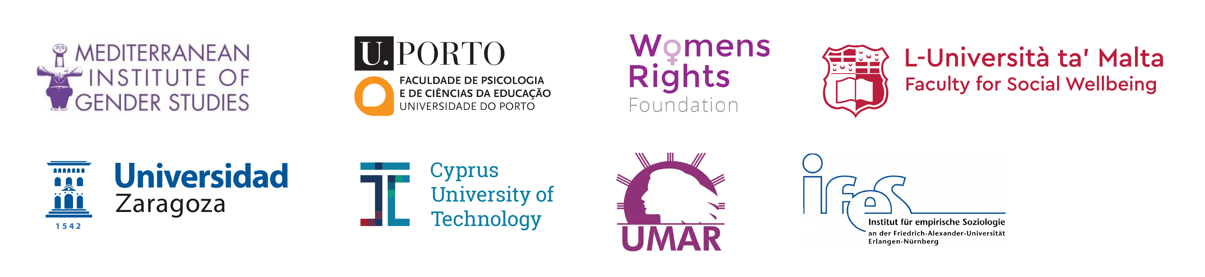
The FEM-UNITED partnership spans five EU countries and includes the Mediterranean Institute of Gender Studies; the University of Malta; the Cyprus University of Technology; the Institute for Empirical Sociological Research at the University of Erlangen-Nuremberg; the University of Zaragoza; the Women’s Rights Foundation, and the UMAR – União de Mulheres Alternativa e Resposta.

